**Prompt**

The main goal of this phase is to obtain a hands-on understanding of the problem and show that your idea is feasible on the proposed scale. Whereas Milestone 2 gave some initial steps to verify that you could work on the proposed project, this milestone will produce something that forms a foundation for a larger overall solution and brings a clearer vision of how to accomplish it. For example, you could build a software artifact that works with limited functionality or data or carry out theoretical work that uses assumptions that you will work to modify/remove.

What to turn in If your project is primarily software development, provide a 2-4 page writeup that describes the state of the code, its limitations, and how these will be addressed in later stages of the project.

Annotate your initial proposed timeline with the tasks that are completed, or, if your timeline has changed, give your updated timeline with a justification for the changes. Also, clearly describe how the workload has been distributed across team members.

Finally, you should restate your proposed meeting plan with your faculty mentor, how you kept to this plan, as well as a summary of what was accomplished during these meetings

Also, be sure to include thorough references; you will have some initial references from Milestones 1 and 2, which should be significantly expanded upon for this milestone. Published sources should contain standard bibliographical info (at minimum authors, title, venue/book/journal, year, and pages). Online sources should contain working links. For theoretical results, only the articles published in peer- reviewed conference and journal papers, and books, are allowed sources. For practical projects, other public sources (such as Wikipedia, StackOverflow, Reddit, TechCrunch, Wired and the like) are allowed as long as you have critically assessed them and reasonably believe them to be true. You should follow one of the commonly used in-text citation and reference styles (e.g., ACM, APA, or IEEE).

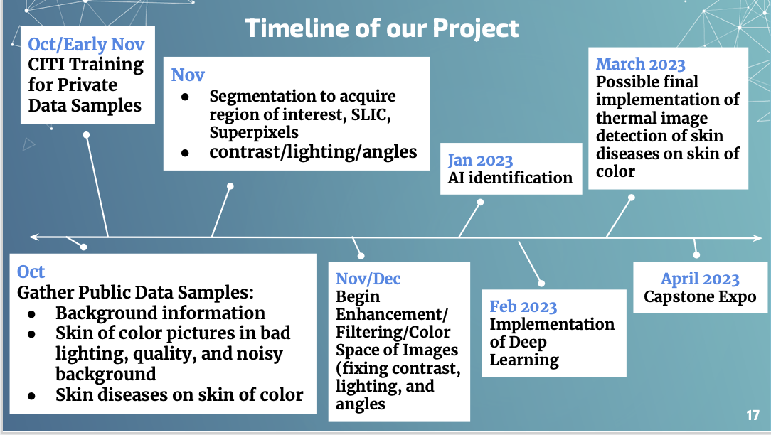

.

|  | **Chenyu** | **Reagan** | **Charles** | **Jamie** | **Total** | **Avg** |
| --- | --- | --- | --- | --- | --- | --- |
| bad | 48 | 64 | 55 | 41 | 208 | 32.00% |
| mid | 37 | 78 | 38 | 63 | 216 | 33.23% |
| good | 81 | 18 | 67 | 58 | 224 | 34.46% |
| Individual total | 48/165  37/165  81/165 | 64/160  78/160  18/160 | 55/160  38/160  67/160 | 41/162  63/162  58/162 | 648 + 2 with no result so 650 | 0.31% for 2 images with no result |

Jamies and Charles both have 1 image with no result